PROJECT DEVELOPMENT PHASE

PERFORMANCE TEST RESULTS

Project Name: Metro Ticket Generating System in ServiceNow

1. Test Execution
Parameter | Details
Project | Metro Ticket Generating System
Environment | ServiceNow PDI
Interface | Service Portal
Browser | Microsoft Edge
Tester | Konathala venkata satyalakshmi

2. Test Results

Test ID | Scenario | Actual Result | Status
PT01 | Open Service Portal | Service Portal opened successfully | Pass
PT02 | Open Catalog Item | Book A Metro Ticket opened successfully | Pass
PT03 | Load Booking Form | Required variables loaded correctly | Pass
PT04 | Select Stations | Starting and Destination stations selected successfully | Pass
PT05 | Fare Calculation | Fare calculated automatically | Pass
PT06 | Journey Type | Fare updated when journey type changed | Pass
PT07 | Payment Mode | Dependent payment field behaved correctly | Pass
PT08 | QR Generation | QR code generated successfully | Pass
PT09 | Submit Booking | Request generated successfully | Pass
PT10 | Request Processing | Booking details displayed in requested item | Pass

3. Performance Observations
During testing, the Service Portal and Metro Ticket catalog item loaded successfully. Station selection, passenger count, fare calculation, payment-mode logic, QR generation, and request submission worked as expected during normal usage. No significant performance issues were observed during the test execution.
4. Test Evidence
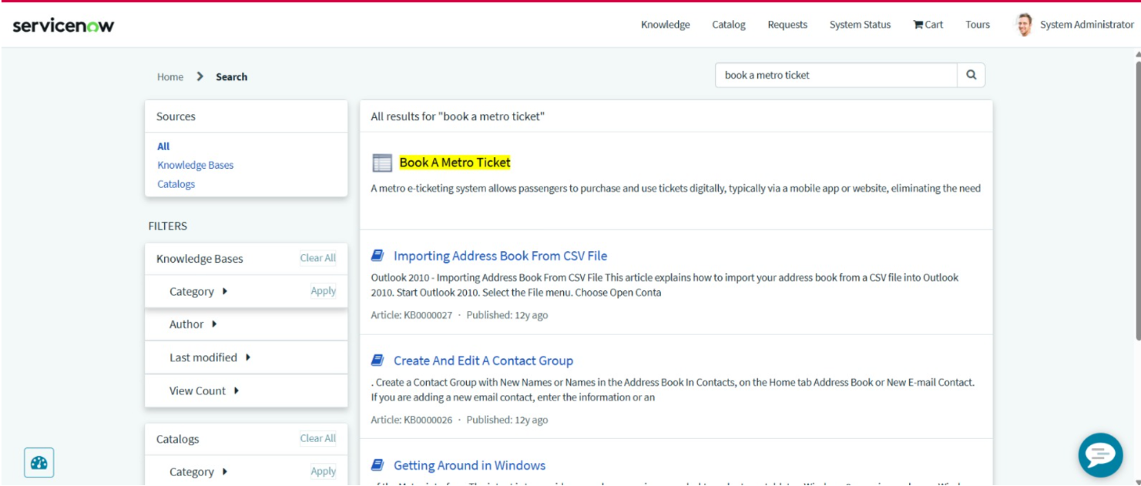
Figure 1: Service Portal displaying the Book A Metro Ticket catalog item
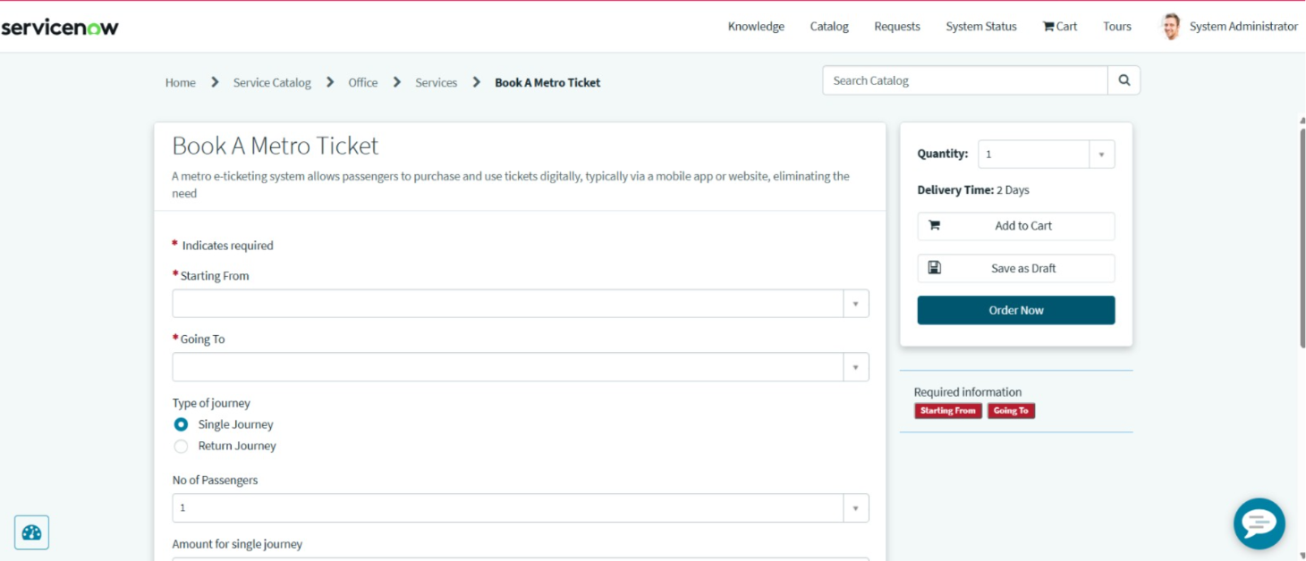
Figure 2: Metro ticket booking form with journey and passenger details

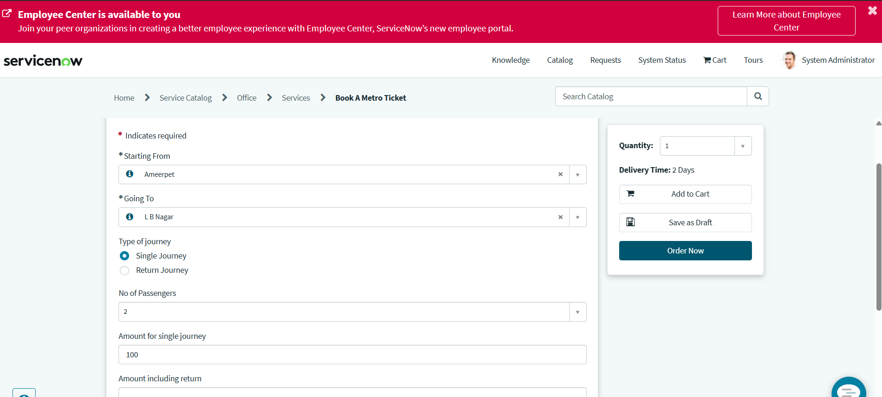Figure 3: Dynamic fare calculation based on journey details and passenger count
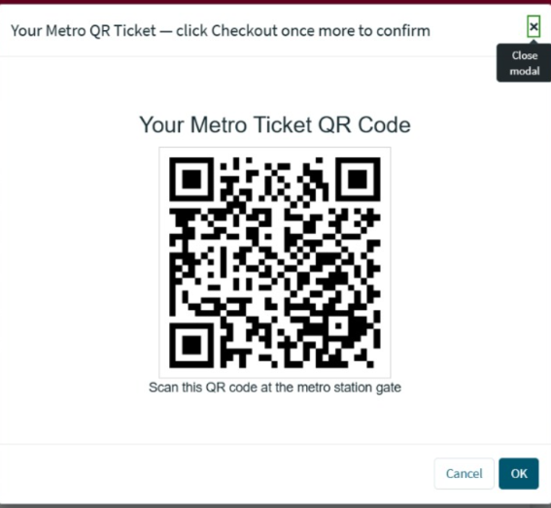
Figure 4: Metro QR Widget displaying the generated digital ticket QR code

